Course-End Project-1:
Implementing a project to host a gaming application for an Electronics Arts company on modern cloud infrastructure for video game lovers, teenagers & school going kids via Azure Devops CI/CD pipelines.
Project Agenda: Hosting a gaming application on modern cloud infrastructure via azure devops CI/CD pipelines.
Description:
Electronic Arts is one of the reputed video games companies for designing and Implementing variety of video games, it is based in the south Asian countries like(Japan, China, Singapore, Australia, Taiwan India. Etc). It helps end users/purchasers with different gaming apps, software’s both for mobile and desktop.
Electronic Arts IT department treats its gaming software’s as mission-critical and wants it to be available all the time, as in its absence, they will not be able to give a best impression and experience for their customers of their products, which can result in business loss.

Technical briefing of the Project:
This project will divide in 2 parts. i.e: Build pipeline & Release pipeline and in Build Pipeline if developers makes any change in git hub repository it will trigger the build pipeline and pulls the code from git hub repository and build the docker container image and push it to the Azure container registry
Release Pipeline will be automatically get triggered and it will pull the artifact from the build pipeline which is an image in ACR and this image it will deploy on the Azure Container App on the Azure App Services and hence will able to see the changes on the gaming application.

Architectural Diagram of Project Workflow:
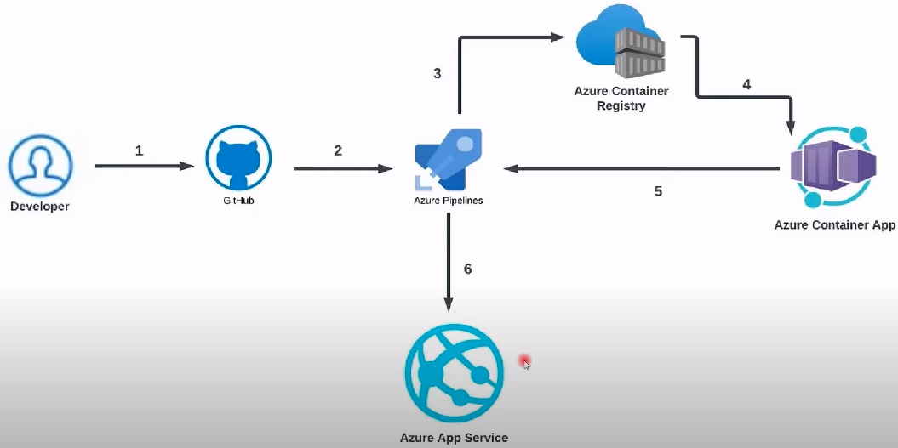 Azure Devops REAL-TIME-END-TO-END-PROJECT

Pre-requisites to develop this project:
- Azure Active Subscription in both the below portals
(https://portal.azure.com & https://dev.azure.com )
- Granted approval for parallelism from Microsoft for CI/CD pipelines.
- Good Internet connection
- Laptop(any configuration)

In this project we are implementing:
- Resource Group(RG)
- Azure Docker container registry
- Creation of an Organization & Private projects in Azure devops
- Establishing service connection for ACR & GitHub in Devops
- Building CI/CD pipeline in devops project for ACR
- Creating an App service in Azure portal
- Releasing of CI/CD pipeline to Azure App service deployment
- Access the application on web browser.
- Verifying the CI/CD pipelines by making test commit
- Modify the application by enhancing the project code from GitHub using #git commands.
- Build/Release of the pipelines(CI/CD pipelines) starts again as part of an automation.
- Testing the gaming application
- Finally verify the application again in the web browser.

Refer the below video link to develop the project step by step with all technical steps(in detail):
Azure DevOps Project from Scratch | End to End Azure Project | Complete Azure DevOps Project (youtube.com)

